# How to start a django setup



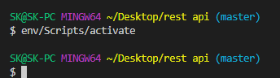

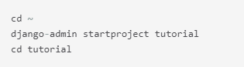



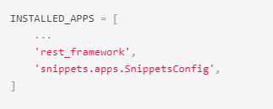

# Vip point read first

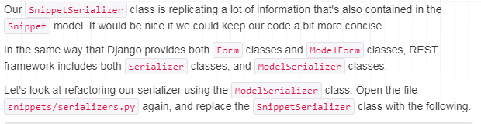

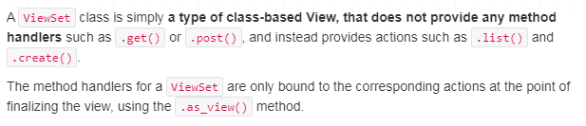

If use viewset method in views.py class, we can not user get are post method under this class, because it is default .

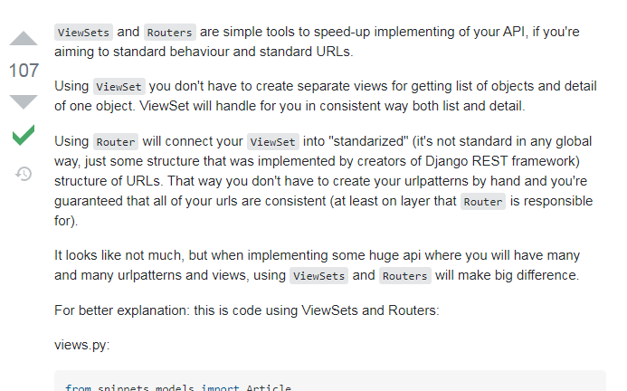

# All category Rest api views details

<https://micropyramid.com/blog/generic-functional-based-and-class-based-views-in-django-rest-framework/>

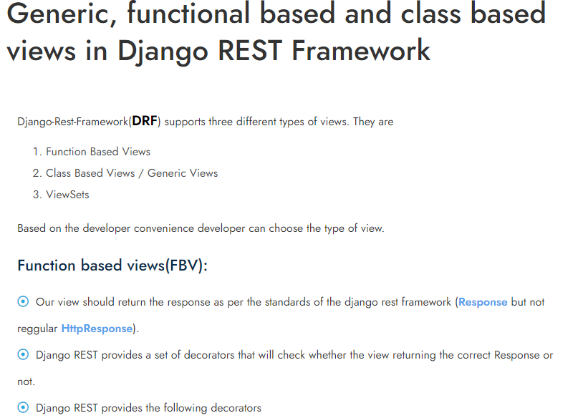

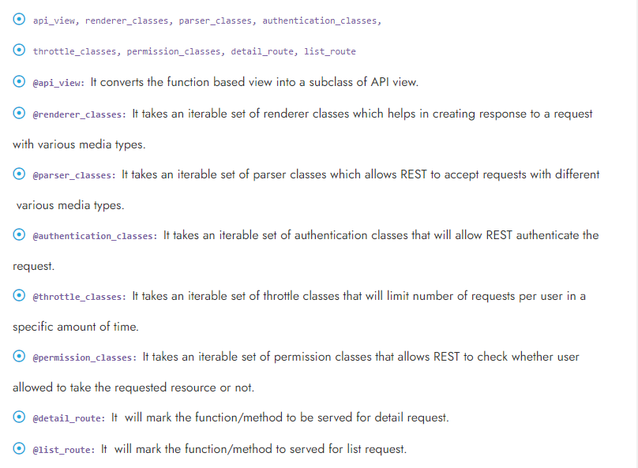

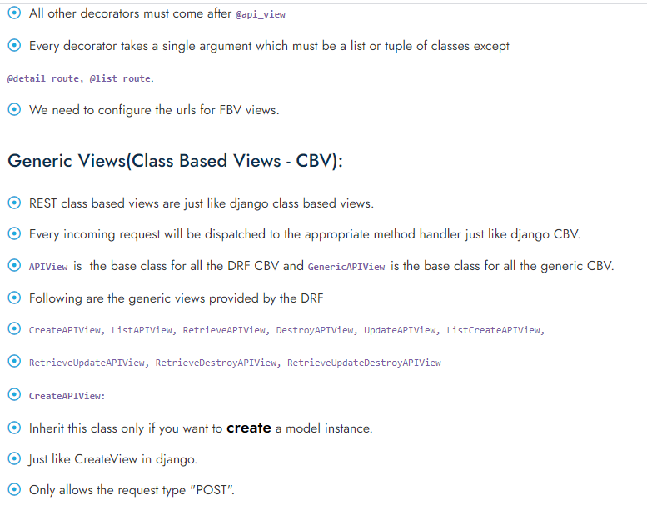

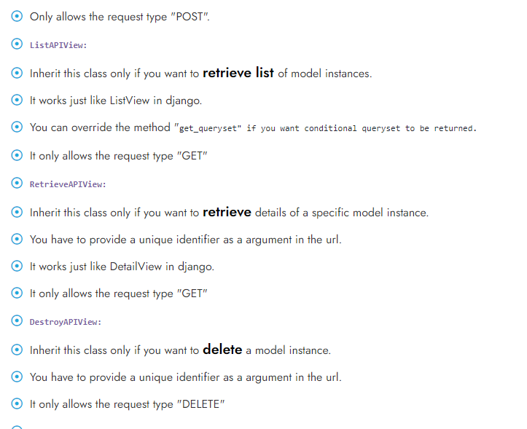

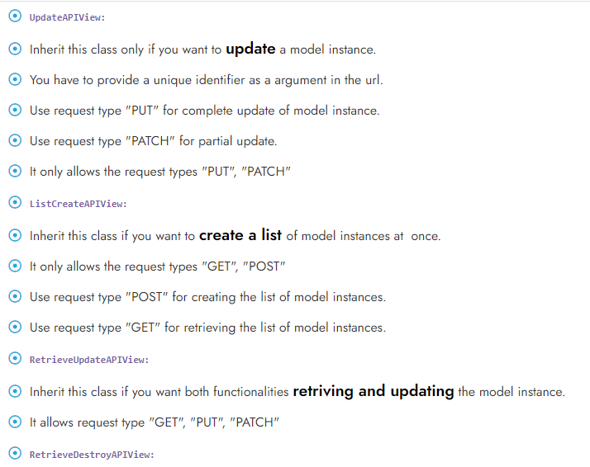

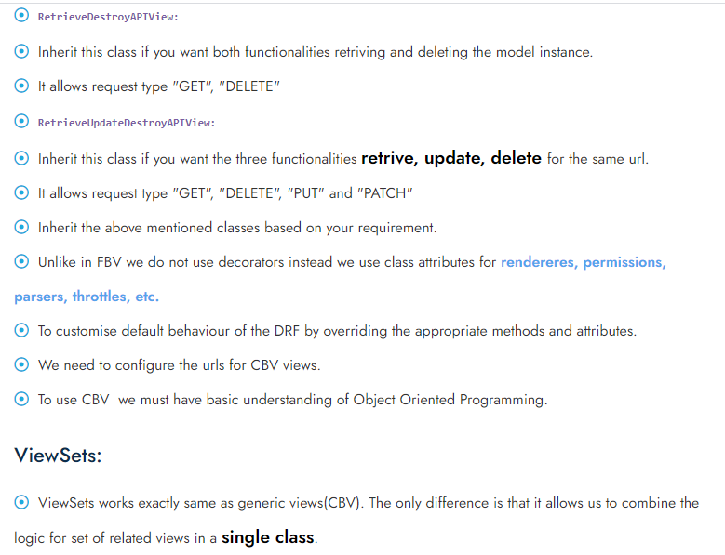

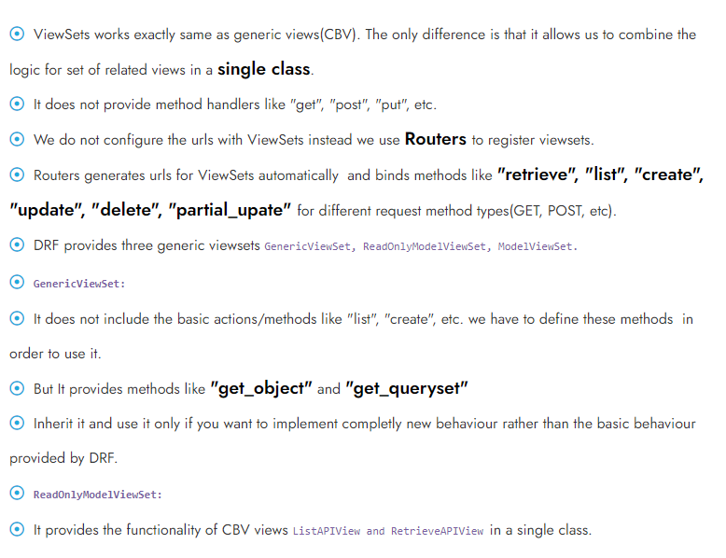

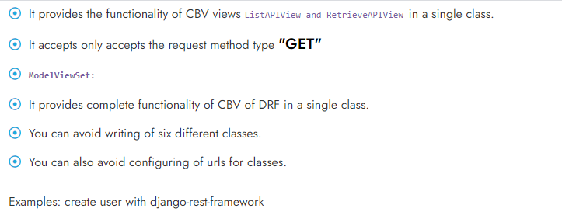

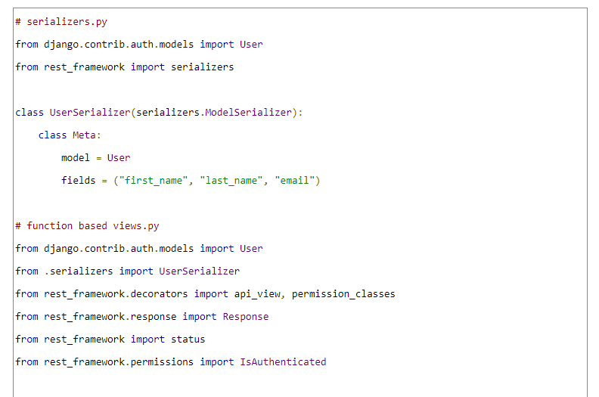

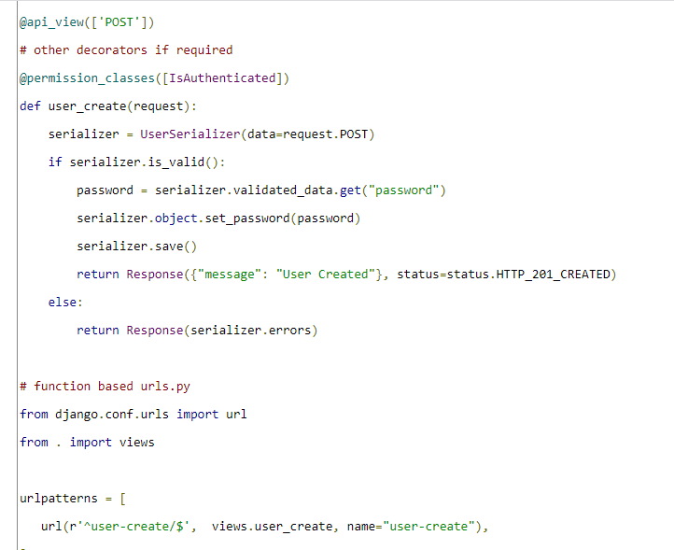

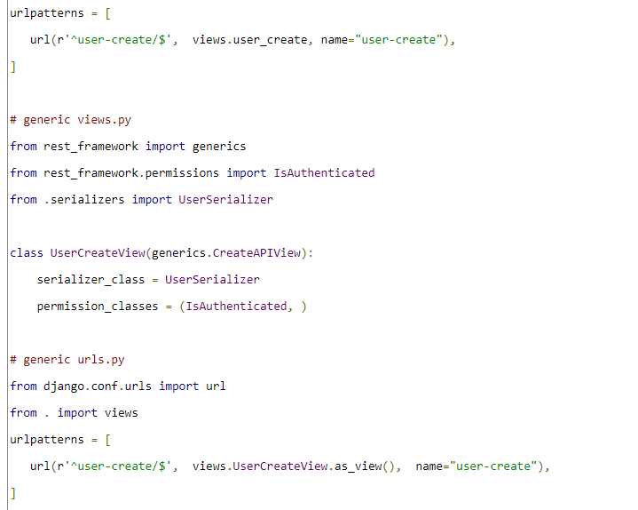

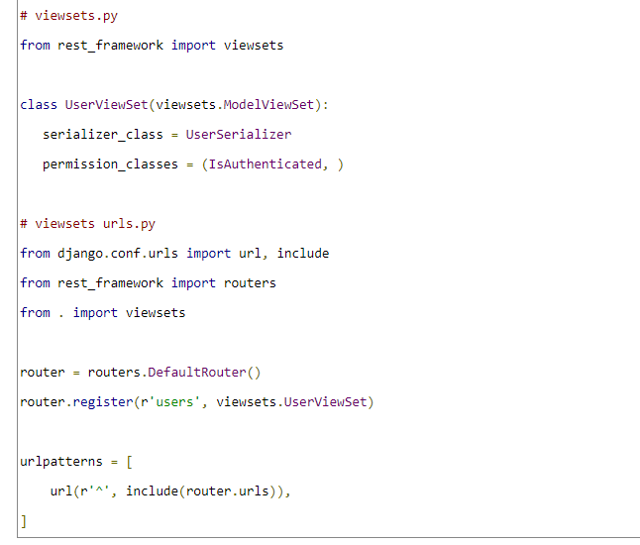

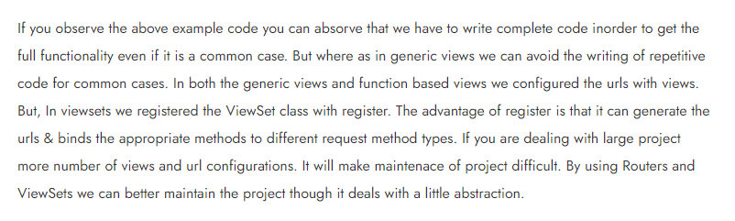

# In serializers.p details

1.serilizers.Serializers

2. serializers.ModelSerializer

# In views.py details

1. views.APIView
2. views.genericView
3. viewsets.ViewSet
4. viewsets.ModelViewset

# pactics1. CRUD operation by only Viewset.ModelViewset , and Route

in this project app urls.py not use

# pactics2. CRUD operation by only Viewset.ModelViewset , and Route

in this project app urls.py use

# pactics3.only get request by using genric.ListAPIview

# pactics4.only delete request by using genric.DestroyAPIview

# pactics5.only post request by using genric.CreateAPIview

# pactics6.only update request by using genric.UpdateAPIview

# pactics7.only single end point view request by using genric. RetrieveAPIview

ey view er jonne urks a pk use korte hobe

# pactics8.total CRUD project by using by using (generic.ListCreateAPIView) and (genric. RetrieveUpadteDertroyAPIview)

# rest api permission details

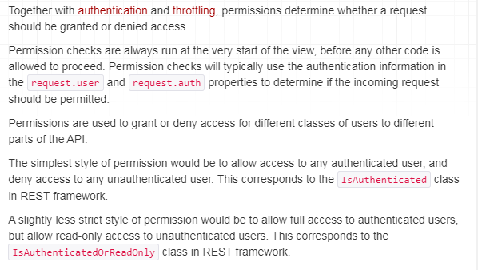

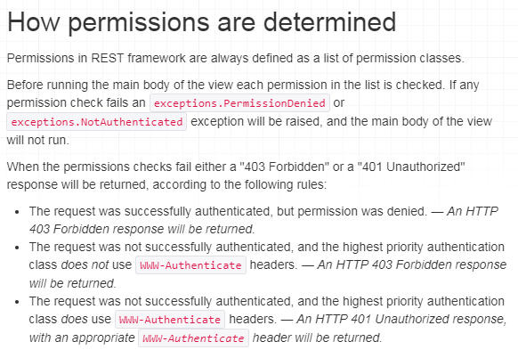

## Permission classification

In rest api permission are three lavel permission . othat 3 vabe permission create kora ji

### 1.Project lavel permission: eta dite hoy setting.py file teke

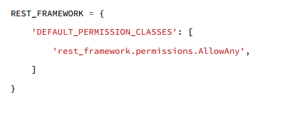

Or

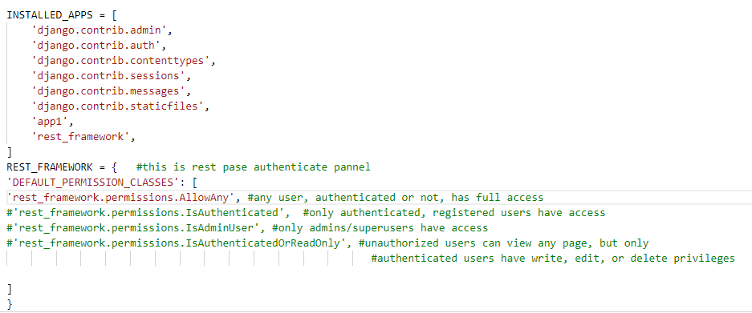

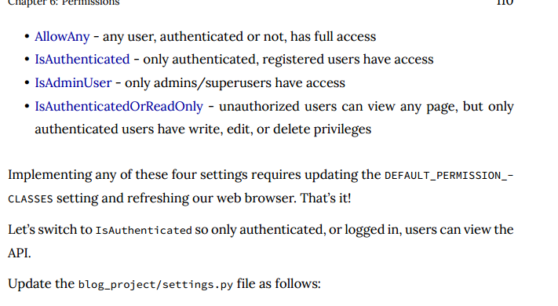

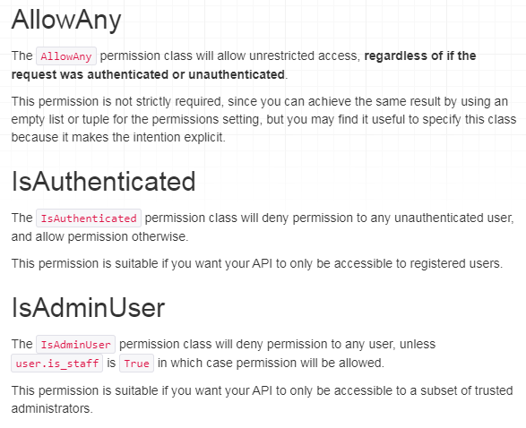

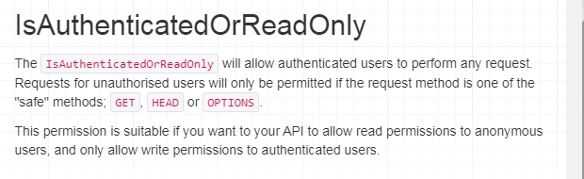

#### Example:

### 2.View lavel permission: eta dite hoy views.py file teke, Etar jonne view.py file a add korte hoy

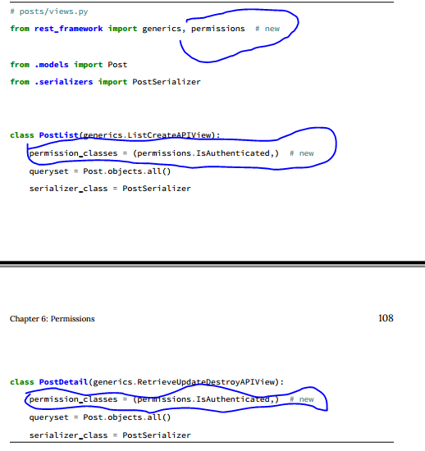

#### Example:

### 3.Object/customize permission: eta dite hoy permission.py file teke

It combination of project level and object level permission

Eta muloto, superuser login korle ga post,put,delete option pabe ta sara onno sub user login talke sudo show korte parbe all data and end point data both

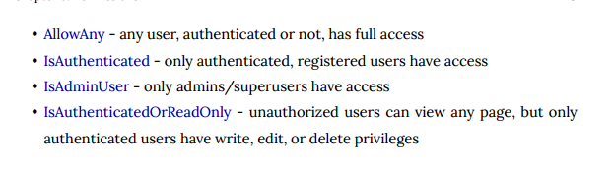

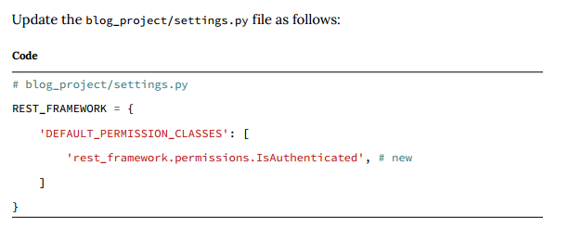

#### Example:

### 4.Custom permissions

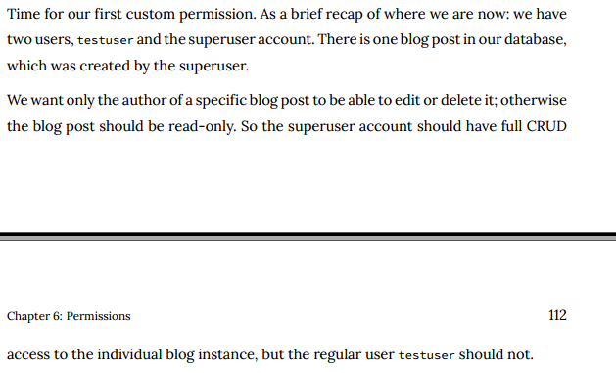

#### custom permission types

Permission.py fie create kore nicher j kono way te permission lika ji ,ja porobotite ,views.py file a add kore dite hoy

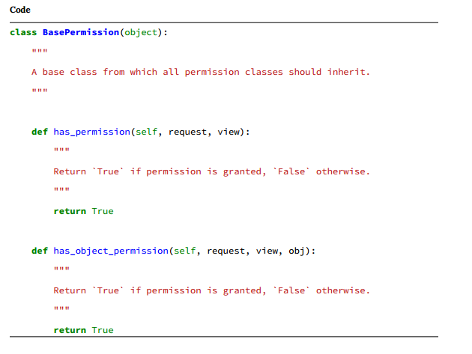

#### Example:

Let ,

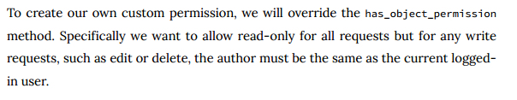

##### Permission.py

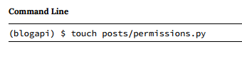

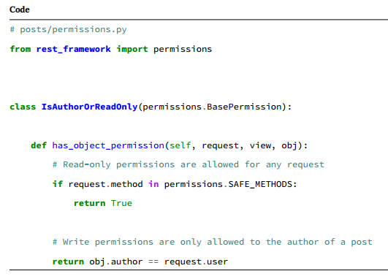

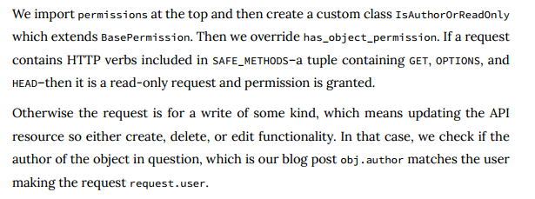

##### Views.py

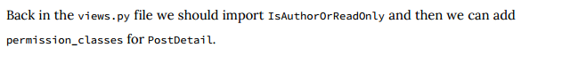

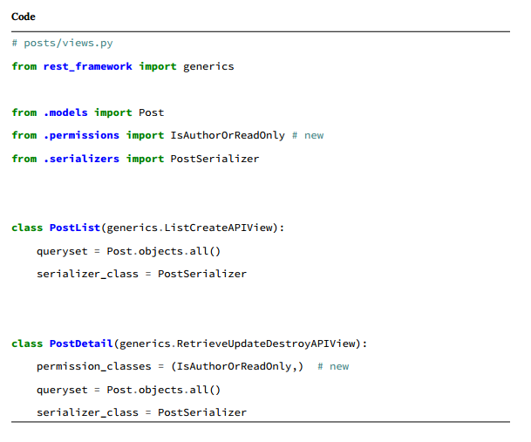

##### Result:

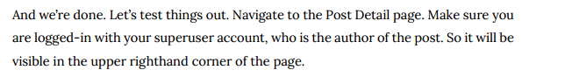

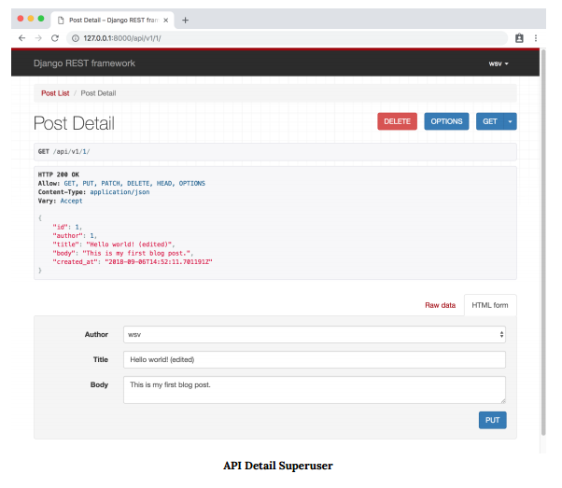



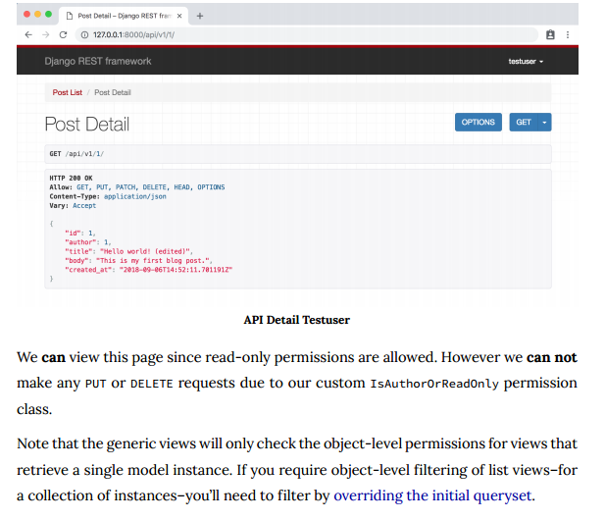

# [Difference between APIView class and viewsets class?](https://stackoverflow.com/questions/41379654/difference-between-apiview-class-and-viewsets-class)

[Ask Question](https://stackoverflow.com/questions/ask)

# The DRF APIView, GenericAPIView, ViewSet